

**Special Educational Needs and Disabilities (SEND) Policy**

**September 2023**

**Version Control**

|  |  |  |
| --- | --- | --- |
| **Category:** | Inclusion | |
| **Authorised By:** | TLET Safeguarding and Standards Committee | |
| **Author:** | M. Barker (updated by J. Higham) | |
| **Version** | 3 | |
| **Status:** | Under Review: |  |
| Approved: | ✔ |
| **Issue Date:** | September 2023 | |
| **Next Review Date:** | September 2024 | |
| **Statutory Policy:** | Yes | ✔ |
| No |  |
| ***Printed Copies Are Uncontrolled*** | | |

**Contents**

|  |  |
| --- | --- |
| **Section** | **Page** |
| 1. The TLET Way | 4 |
| 2. Definition of Terms | 5 |
| 3. Rationale and Statutory Requirements | 6 |
| 4. Scope | 6 |
| 5. Principles | 9 |
| 6. Policy Statement | 10 |
| 7. Procedure | 10 |
| 8. Education, Health and Care (EHC) Plans | 12 |
| 9. Working with Parents | 13 |
| 10. Access to extra-curricular activities | 14 |
| 11. Transition arrangements | 14 |
| 12. Complaints | 14 |
| 13. Further Support | 14 |
| 14. Local Offer | 14 |
| 15. Monitoring | 15 |
| 16. Related Documents | 16 |

**1 – The TLET Way**

Transforming Lives Educational Trust (TLET) is a family of academies. Every TLET policy is rooted in and reflects our ambitions for pupils, students and wider stakeholders alike. Our ambitions are to **Nurture Potential, Inspire Community and Deliver Excellence.**

Through the transformative values of **courage, kindness** and **loyalty** we:

* Nurture Potential - We flourish in the places we create together.
* Inspire Community - We champion each other to make a difference.
* Deliver Excellence - We strive to achieve our best.

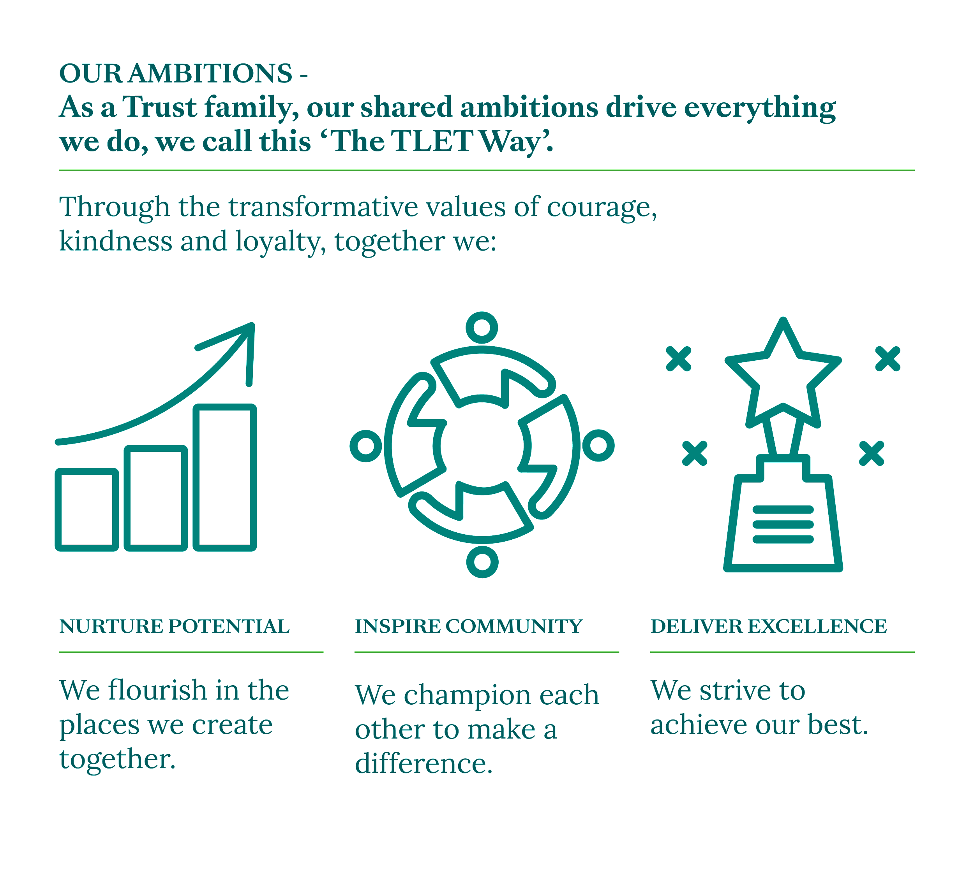

**2 – Definition of Terms**

**2.1 Parent or Carer**, for the purposes of this policy, refers to the adult/s who hold parental responsibility or with whom the child normally resides.

**Pupil**, for the purposes of this policy, refers to a child, student, or young person who attends an academy within the trust.

**School**, for the purposes of this policy, refers to an academy within the trust.

**Trust**, for the purposes of this policy, refers to Transforming Lives Educational Trust, including its academies.

**Code of Practice**, refers to The SEND Code of Practice (2015)

**2.2 Definition of Special Educational Needs**



The SEND Code of Practice (2015) provides an overview of the range of needs, which are divided into four broad areas. The Trust recognises that pupils are likely to demonstrate difficulties across these areas:

|  |  |
| --- | --- |
| **Communication and Interaction**  This includes difficulties communicating with others due to speech and language communication needs or those who do not readily understand the social rules of communication. This is likely to include pupils with developmental language difficulties as well as those on the Autistic Spectrum. | **Cognition and Learning**  This is where children demonstrate difficulties accessing, retaining, or applying learning.  Children may exhibit moderate learning difficulties, specific learning difficulties, or profound and multiple learning difficulties. |
| **Social, Emotional and Mental Health**  This includes difficulties where children may be withdrawn or isolated, as well as displaying challenging, disruptive or disturbing behaviour. These behaviours may reflect underlying mental health difficulties such as anxiety, depression, eating disorders as well as diagnosed conditions of attention deficit (hyperactive) disorder or attachment disorder. | **Physical and Sensory**  This may include a vision or hearing impairment, or multi-sensory impairment which means that the pupil requires specialist support and/or equipment to access their learning. |

**3 – Rationale and Statutory Requirements**

3.1 This policy complies with the statutory requirements as laid out in the SEND Code of Practice 0-25 (2015) and has been written with reference to the following documents:

* Equality Act 2010: Advice for Schools (DfE, May 2014)
* Mental Health Act 2007

**4 – Scope**

This policy refers to…… (Tick as appropriate)

|  |  |  |  |
| --- | --- | --- | --- |
| **Parents/Carers** |  | **Trustees** | ✔ |
| **Employees** | ✔ | **Volunteers** | ✔ |
| **Pupils/Students** |  | **Visitors** |  |
| **Governors** | ✔ | **Community** |  |

**4.1 Roles & Responsibilities**

**4.1.1 Our SENCOs are:**

**Ashlawn School –** Dean Merrick

**Henry Hinde School (Grenville Close) –** Rachel Howard

**Henry Hinde School (Cornwallis Road)** - Rachel Howard

**Houlton School –** Becky Cooper

* Each of our SENCOs are qualified teachers who work at the school.

They have either completed or are working towards the National Award in Special Educational Needs if they are new to post.

* Our SENCOs are responsible for the day-to-day operation of the SEND Policy and coordination of provision for pupils with SEND. This includes keeping up to date records on all pupils with SEND.
* Our SENCOs provide advice to all staff in inclusive practice and specialist provision for our pupils.
* Our SENCOs liaise with pupils, parents, staff and health and educational professionals including the Local Authority.
* Our SENCOs advise on how the school’s delegated budget and resources are used to meet pupils’ needs effectively.

**2 The Role of the Pupil**

In line with the Code of Practice and Section 19 of the Children and Families Act 2014, we endeavour to:

* Seek and respond to the views, wishes and feeling of the child or young person
* Provide opportunities for pupils to participate as fully as possible in decisions.





**5 – Principles**

**5.1 What do we want for our pupils?**















**6 – Policy Statement**

TLET is committed to:

* Ensuring that the quality of inclusive teaching is high across all academies
* Establishing effective methods of identification across the Trust;
* Enabling all SEND pupils to join in the activities of the academy together with pupils who do not have SEND as far as is reasonably practicable;
* Providing professional development for all staff in removing barriers to learning and maximising learning potential;
* Making SEND provision an integral part of each academy’s Improvement Plan;
* Providing our academies with expert support and advice, and where possible providing cross-Trust opportunities for staff development;
* Regularly monitoring the progress and development of all pupils throughout each academy.

**7 – Procedure**

**7.1** **How do we identify pupils with SEND?**

Each Academy uses the following identification strategies:

**7.1.1 Listening and responding to our pupils and their parents and carers**

*If a pupil or parent/carer raises a significant concern, an assessment is carried out of their needs through a ‘Pupil Capture’. This includes observations, collation of the pupil’s assessments and progress and reflection with the SENCO and relevant teachers.*

**7.1.2 Information from our pupil’s prior setting through the transition process**

*On entry, information is sought from the pupil’s previous setting and from parents/carers. Baseline assessments are carried out within the first few weeks of entry which may or may not result in additional provision.*

**7.1.3 Teacher Observation and Assessment**

*All our staff are trained in the early identification of a range of Special Educational Needs through regular staff training audits and updates. Where staff are concerned about the progress of one of their pupils they will raise a concern with the SENCO. Additional assessments and observations will then be made through the ‘Pupil Capture’ process.*

**7.1.4 Pupil Progress Meetings**

*All our academies carry out regular pupil progress reviews with Senior Leadership and relevant staff to set and review aspiring targets for all our pupils. Where a pupil is not making the progress we would anticipate, a school concerns form will be completed, and they may be added to the SEND register.*

**7.1.5 Assessments by External Agencies**

*Where external agencies are already involved in supporting pupils, their work will help inform the assessment of need.*

**7.2 Plan, Do and Review**

**7.2.1 SEND Support**

Where a period of high-quality inclusive teaching with targeted adaptive support has not resulted in the pupil making good progress, or where the nature or level of the child’s needs are unlikely to be met by such an approach, provision may need to be made and the pupil will then be placed on the school’s SEND register.

The pupil’s class or subject teachers remain responsible for planning, delivering and reviewing an individualised programme of learning, with the support of the SENCO. At Henry Hinde School, these are referred to as IEPs (Individual Education Plans), at Ashlawn School and Houlton School these are referred to as Learning Plans or Passports.

Intervention at this stage is additional to or different from the school’s usual differentiated curriculum and strategies.

This could be, but not limited to, in form of:

* The deployment of support staff to enable timetabled one to one tuition or small group tuition (this will depend on financial resources and staff availability);
* The delivery of a specific intervention and the monitoring of its effectiveness;
* Providing different learning materials or special equipment;
* Staff development and training to introduce more effective strategies;
* One-off or occasional advice from the Local Authority (LA) support services.

This programme of learning, where possible, is agreed and reviewed with the pupil, parents and any external agencies working with the pupil.

The pupil’s class or subject teachers will complete assessments of the pupil’s strengths and needs as required, with the SENCO facilitating any external assessments where applicable. Parents should always be consulted and kept informed of the action taken to help the child, how they can help at home and the outcome of any action taken by the academy.

**8 – Education, Health and Care (EHC) Plans**

**Applying for an Education, Health and Care (EHC) Plan**

If a pupil fails to make progress, we may apply for the pupil to be assessed for an EHC Plan. As detailed in part of the SEND Code of Practice, a request is made for an EHC Plan when the provision made from the school’s own resources is not sufficient in enabling the pupil to make adequate progress. Parents are entitled to refer directly for an Education Health Care Plan assessment, but where possible we would seek to make this referral for you. For further guidance, please see SEN03 EHC Needs Assessment: Criteria and Referral Process available at:

https://www.warwickshire.gov.uk/send-resources/ehc-needs-assessment-documents-templates/5

**Reviewing the Education, Health Care (EHC) Plan**

In line with the SEND Code of Practice, a learner’s EHC plan will be reviewed at least annually through a personalised approach. Where there is an anticipated change of setting or concern around the level of provision, this can be sooner.

The pupil, parents, and carers as well as all relevant professionals will be invited to contribute to this process through attending the review in person or via an online meeting. Where this is difficult, professionals will provide a written report or separate interview; as a Trust we will work hard to ensure that all EHC review meetings have both parents/carers and learners in attendance for at least part of the review. During the review, there will be opportunities to review the impact of the provision in place, celebrate success as well as identify areas for development and any changes required to the existing provision in place.

We pride ourselves on our inclusive ethos and will make adjustments to ensure that all learners have the provision they need to fulfil their potential in our mainstream settings. Where a learner is demonstrating significant difficulties accessing learning with the provision in place, we will seek to work with parents and carers, external professionals, and the Local Authority to explore all options. This may include the securing of additional funding so that the learner can access additional adult support, use of a reintegration plan and in rarer situations, a managed move or application to a special provision in line with Warwickshire Fair Access Protocol.

**9 – Working with Parents**

We see parents and carers as partners in their children’s learning and the ‘experts’ in their child.

We aim to promote effective relationships with all our parents and carers through the following strategies:









**10 – Access to extra-curricular activities**

All our children have equal access to before school, lunchtime and after school clubs which develop engagement with the wider curriculum. Where necessary, we make accommodation and adaptation to meet the physical and learning needs of our children. Class trips are part of our curriculum, and we aim for all children to benefit from them. No child is excluded from a trip because of SEN, disability, or medical needs.

**11 – Transition Arrangements**

We understand how difficult it is for children and parents as they move into a new class/school year or a new school and will do what we can, according to the individual needs of the child, to make all transitions as smooth as possible. This may include, for example:

* Additional meetings for the parents and child to build relationships with school staff;
* Additional visits to the areas of the school pertinent to the pupil;
* Being provided with transition books and guides with photographs of key people and places;
* Enhanced transition arrangements being tailored to meet individual needs.

**12 – Complaints**

TLET strive to care for each individual pupil and provide the best education possible to suit the child’s learning needs. Regrettably, there may be times when complaints arise and parents and carers are encouraged to contact the school quickly if a problem occurs so that a solution can be found.

Each academy has an individual complaints procedure detailed on their website.

**13 – Further Support**

Warwickshire SENDIAS (Special Education Needs Information Advice and Support Services) supports parents and carers of all Warwickshire children with special educational needs and disabilities, from 0 - 25 years of age.  It is a free, confidential, and impartial service for parents and carers, children and young people up to 25 years.  Warwickshire SENDIAS offers independent support for parents and families who have children and young people with a SEND.  They also provide this independent advice directly to young people aged 16 to 25 years with SEND.

To speak to a member of their team, call 024 7636 6054, or e-mail warwickshire@kids.org.uk or contact them via post to KIDS, Exhall Grange Specialist School, Easter Way, Off Pro Logis Park, Coventry CV7 9JG.

**14 – Local Offer**

Warwickshire has a Local Offer section on their council website https://www.warwickshire.gov.uk/send. You can find out about support and services available for your child or children and young people (0-25) with SEND (Special Educational Needs and Disabilities). Information can be found here about Education, Health and Social Care services.

**15 – Monitoring**

15.1 It is the responsibility of the Board of Trustees, and those they delegate authority, to ensure that the principles and procedures of this policy are adhered to. The use of this policy will be subject to routine monitoring to ensure its fidelity in practice. The evidence gathered from monitoring at regular intervals shall inform any reviews and future revisions to the policy, and no later than that stated on Page 2 of this policy.

**Each Academy within TLET operates its SEND provision under this policy but also maintains its own detailed SEND procedures and produces an annual SEND Information Report. These procedures set out the names of those responsible for the operation of TLET’s SEND Policy at each academy and can be found on the websites of the individual academies.**

15.2 This policy has been equality impact assessed and we believe that it is in line with the Equality Act 2010 as it is fair, it does not prioritise or disadvantage any individual (with due regard to their protected characteristics), and it helps to promote equality across the Trust.  This policy is to be read in conjunction with the schools’ accessibility policy which details the schools’ individual approach to ensure an accessible environment for all our school community.

**16 – Related Documents**

(Academy) Accessibility Plans

(Academy) SEND Information Reports

TLET Equality and Diversity Policy

**References:**

Department of Education. Department of Health (2015) Special Educational Needs and Disability code of practice 0-25 years. Available at: https://www.gov.uk/government/publications/send-code-of-practice-0-to-25