Design and Technology
Medium-Term Plans (Year 4)
2025-2026
Equipping Children for a World of Possibilities



Subject Medium-term Plan (Year 4 Autumn term)
Year Group  4 | Term  Autumn 2 |  | Unit of Learning  Structure/Design - British Inventors
About the unit  Children will learn about British Inventors and how their inventions changed life at the time and how it has changed our lives today. Children will design a creation to solve an everyday problem. |  | Design Brief:  Children will be able to create their own Victoria toy using a at least one moving part.
Prior Learning  In KS1, design products for themselves and others, generate and develop ideas, select from and use a range of materials, explore and evaluate existing products and evaluate their own ideas against design criteria. | Vocabulary  British, inventor, toys, Victorian, gears, pulleys, cams, levers, linkages, strengthen, Product, Stiffening, Reinforce, Structure, Join, Choose, Qualities, Make, Components, Material, Appearance, Strengthen, Stiffen |  | Resources  Paper  Straws  Card  Boxes  Range of materials  Cams, levers etc.
Assessment (By the end of this unit the children will be able to know, uses and make a moving mechanism)

Key stage 2
Through a variety of creative and practical activities, pupils should be taught the knowledge, understanding and skills needed to engage in an iterative process of designing and making. They should work in a range of relevant contexts [for example, the home, school, leisure, culture, enterprise, industry and the wider environment].
When designing and making, pupils should be taught to:

Design- use research and develop design criteria to inform the design of innovative, functional, appealing products that are fit for purpose, aimed at particular individuals or groups. Generate, develop, model and communicate their ideas through discussion, annotated sketches, cross-sectional and exploded diagrams, prototypes, pattern pieces and computer-aided design
Make- select from and use a wider range of tools and equipment to perform practical tasks [for example, cutting, shaping, joining and finishing], accurately. Select from and use a wider range of materials and components, including construction materials, textiles and ingredients, according to their functional properties and aesthetic qualities
Evaluate- investigate and analyse a range of existing products. Evaluate their ideas and products against their own design criteria and consider the views of others to improve their work. Understand how key events and individuals in design and technology have helped shape the world.

Technical knowledge: apply their understanding of how to strengthen, stiffen and reinforce more complex structures, understand and use mechanical systems in their products [for example, gears, pulleys, cams, levers and linkages], understand and use electrical systems in their products [for example, series circuits incorporating switches, bulbs, buzzers and motors], apply their understanding of computing to program, monitor and control their products.

Learning Objective | Possible teaching Activities |  | Learning Outcomes
Lesson 1-  To know who William Morris is and explore his work? | 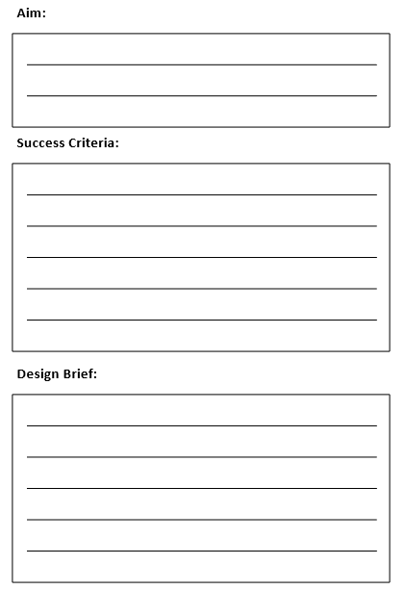  Show children examples of William Morris’ work from the internet.  Discuss the influences on his life and the fact that he grew up in the Victorian era link to his designs being uses in houses in the Victorian era.  When looking through his work, ask children questions: What are the main features? Have they seen these patterns before? Do they like them? Why?  Aim-  To design a Victorian dolls house room with one moving part.  Success criteria-  1 moving part  1 design link to William Morris art designs  Uses a range of join techniques to make a dolls house room with furniture.  Design brief-  Research what Victorian homes looked like and what William Morris’ patterns and designs were like.  Design your own room (for example: a living room, bedroom, or kitchen).  Include one moving feature, such as a door that opens, a window that moves, or a piece of furniture that works.  Use colours, shapes, and patterns inspired by William Morris (floral, nature-inspired, repeating designs).  Make your model carefully, thinking about how it looks and how it works.  A selection of images of William Morris work already in DT booklet for children to minic or copy designs talk about symmetry of his designs and patterns. Show children a symmetrical pattern on the board and identify the lines of symmetry. Show how this is rotational symmetry as well.  Model how to uses a art pencils to continue the pattern. Think about adding colour in later stages.  Complete page 3-4 of DT booklet. |  | I can explore ideas and collect visual information.  I know how to use art materials correctly.  I can continue a pattern to suit the purpose.
Lesson 2-  To know how to sketch a design idea? | 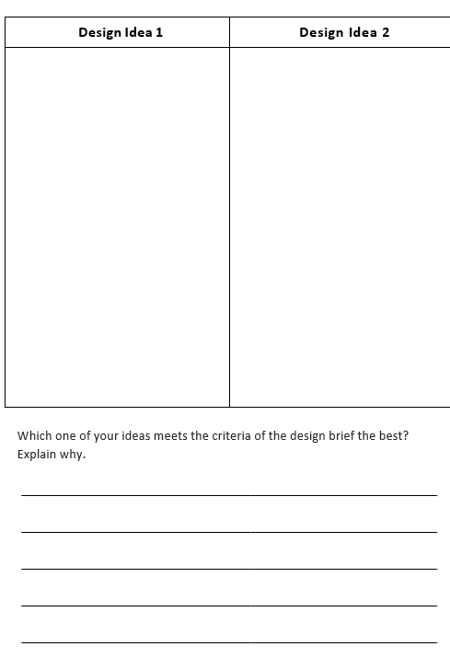  Recap the designs we looked at last week. What do you notice about WM’s work? Explain to children they are doing to be designing a room from a Victorian dolls house but it has to have one moving part.  Children practice a few different stills of making a moving part. Model by teacher.  Then children plan and design 2 ideas of what their Victorian dolls house room might look like, it has to have an aspect of WMs inside the room.  Complete page 5 DT booklet. |  | I can identify lines of symmetry in a pattern.  I can complete a symmetrical pattern.  I can use art materials correctly.
Lesson 3-  To know how to use a stencil to create a repeated pattern based on William Morris’ work? | 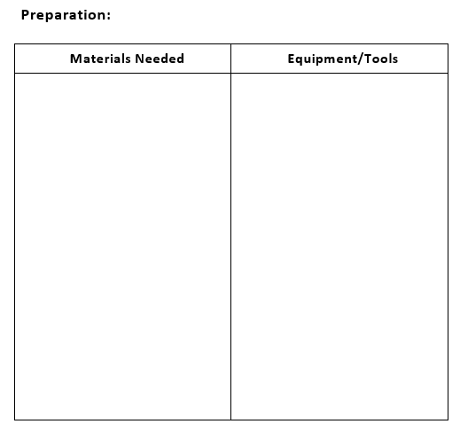  Give children time to look back through their 2 designs from last week. What improvements need to be made?  Give children time to edit their original designs using pencils to make one final design.  Children think carefully what material and equipment they are going to need to make their dolls house room.  Complete page 6/7 of DT booklet. |  | I can create a stencil block.  I can use a range of art materials.  I can create a repeating pattern to mimic William Morris’ work.
Lesson 4-  To know how to design and my own Victorian toy? | 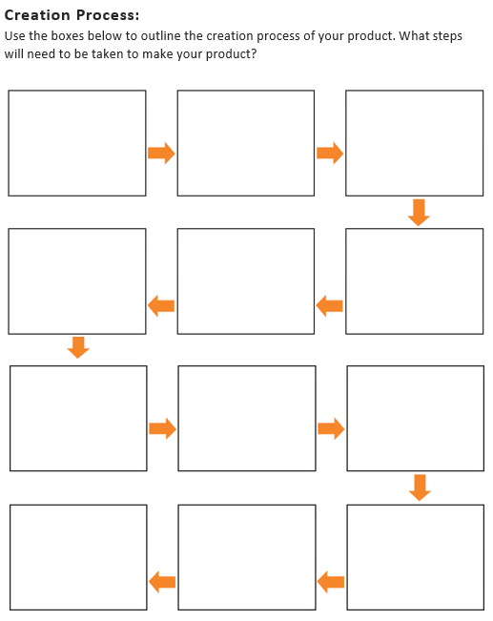  Recap what the children created in previous lesson. What moving part did you make? Who are they for? How are you going to make them?  Where are you going to incorporate WMs work?  Explain that today children are going to use their design from their DT booklets to make their toy using the materials.  Show children the different materials that they could use and model demo how to use them to make a rough idea of a toy. Show them how to use felt tip pens/crayons/paint to decorate them.  Complete page 9 of DT booklet. |  | I can design my own Victorian toy/game.  I can combine a range of materials to make my own Victorian toy/game.
Lesson 5-  To know how to design and make my own Victorian toy? | Recap what the children created in previous lesson of their step by step design progress.  Explain that today children are going to use their design from their DT booklets to make their dolls house room using the materials.  Show children the different materials that they could use and model demo how to use them to make a rough idea of a toys.  Photos of children with the designs to be taken for DT booklet page 11. |  | I can design my own Victorian toy/game.  I can combine a range of materials to make my own Victorian dolls house room.
Lesson 6-  To know how to evaluate your own Victorian toy? | 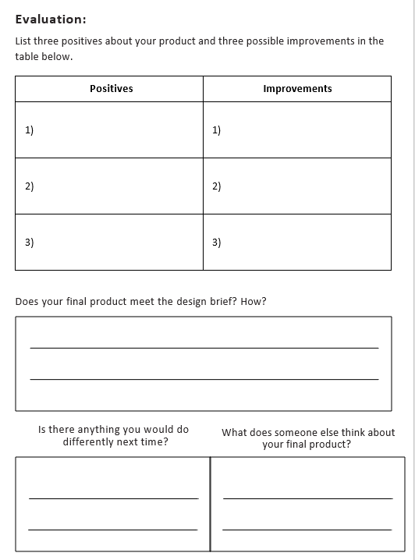  Children to show their finished designs to peers and get feedback.  What toys/games did you make? Who are they for? How are you going to make them?  Complete page 13 of DT booklet. |  | I can evaluate my finished product.

Subject Medium-term Plan (Year 4- Spring term)
Year Group  4 | Term  Spring 2 |  | Unit of Learning  Textiles – Roman Drawstring Purse.
About the unit  Children will learn about pneumatic systems and how these can move parts in a toy/model. Children will explore how these systems work and then follow instructions to create their own models. They will then design, create and evaluate their finished models. |  | Design Brief:  The Romans have had enough! They keep losing things they put in their pockets because they are full of holes! They have asked if you could design something to put their coins and treasures in that will go in their pocket and not be lost.
Prior Learning  In KS1, design products for themselves and others, generate and develop ideas, select from and use a range of materials, explore and evaluate existing products and evaluate their own ideas against design criteria. | Vocabulary |  | Resources
Assessment (By the end of this unit the children will be able to…)

Key stage 2
Through a variety of creative and practical activities, pupils should be taught the knowledge, understanding and skills needed to engage in an iterative process of designing and making. They should work in a range of relevant contexts [for example, the home, school, leisure, culture, enterprise, industry and the wider environment].
When designing and making, pupils should be taught to:

Design- use research and develop design criteria to inform the design of innovative, functional, appealing products that are fit for purpose, aimed at particular individuals or groups. Generate, develop, model and communicate their ideas through discussion, annotated sketches, cross-sectional and exploded diagrams, prototypes, pattern pieces and computer-aided design
Make- select from and use a wider range of tools and equipment to perform practical tasks [for example, cutting, shaping, joining and finishing], accurately. Select from and use a wider range of materials and components, including construction materials, textiles and ingredients, according to their functional properties and aesthetic qualities
Evaluate- investigate and analyse a range of existing products. Evaluate their ideas and products against their own design criteria and consider the views of others to improve their work. Understand how key events and individuals in design and technology have helped shape the world.

Technical knowledge: apply their understanding of how to strengthen, stiffen and reinforce more complex structures, understand and use mechanical systems in their products [for example, gears, pulleys, cams, levers and linkages], understand and use electrical systems in their products [for example, series circuits incorporating switches, bulbs, buzzers and motors], apply their understanding of computing to program, monitor and control their products.
Cooking and nutrition: As part of their work with food, pupils should be taught how to cook and apply the principles of nutrition and healthy eating. Instilling a love of cooking in pupils will also open a door to one of the great expressions of human creativity. Learning how to cook is a crucial life skill that enables pupils to feed themselves and others affordably and well, now and in later life. Pupils should be taught to:
Key stage 2: understand and apply the principles of a healthy and varied diet, prepare and cook a variety of predominantly savoury dishes using a range of cooking techniques, understand seasonality, and know where and how a variety of ingredients are grown, reared, caught and processed.

Be able to create and design a drawstring purse.

Learning Objective | Possible teaching Activities |  | Learning Outcomes
How does a drawstring bag work? | Children will learn how a drawstring bag mechanism works. |  | - Can children identify how a drawstring mechanism works?  - Can children identify where else this mechanism can be used?
What components are needed to make a drawstring bag? | Children will know the components needed to create a drawstring bag. |  | - Can children explain what components are needed to make a drawstring purse?
What joining techniques work best? | Children will know different joining techniques (stitches) used to join fabric together. |  | - Can children investigate ways of joining materials together for the best results?
What design components do I need to include in my design? | Children will continue to develop their ideas about the use of drawstring systems and follow design criteria to design their own product using informed choices. |  | - Can children use their knowledge of drawstring systems to design a Roman drawstring purse?  - Can children describe what materials and components they will need to create their purse?  - Can children identify areas that could be improved upon in their design?
To be able to make a drawstring purse. | Referring to their designs from the previous lesson, children will create their drawstring purses. |  | - Can children create a drawstring purse based on a design?  - Can children construct an effective drawstring system to control movement?  - Can children work safely and effectively with a range of tools and techniques?
To be able to evaluate a finished product. | With reference to their design and product, children will evaluate their product and explain how it was fit for purpose. |  | - Was your product fit for purpose?  - What would you change? Why?

Subject Medium-term Plan (Year 4 - Summer term)
Year Group  4 | Term  Summer 2 |  | Unit of Learning  Cooking and Nutrition - Italy
About the unit  Children will learn about a balanced, healthy diet and how breads can be part of a healthy diet as well as how they originate from Italy. Children will evaluate breads and their origins before designing their own Focaccia. |  | Design Brief:  To design, make and evaluate a traditional Italian Focaccia loaf suitable to accompany an Italian meal
Prior Learning  In KS1, design products for themselves and others, generate and develop ideas, select from and use a range of materials, explore and evaluate existing products and evaluate their own ideas against design criteria. | Vocabulary |  | Resources  Selection of breads  Atlases  Cooking equipment
Assessment (By the end of this unit the children will be able to…)

Key stage 2
Through a variety of creative and practical activities, pupils should be taught the knowledge, understanding and skills needed to engage in an iterative process of designing and making. They should work in a range of relevant contexts [for example, the home, school, leisure, culture, enterprise, industry and the wider environment].
When designing and making, pupils should be taught to:

Design- use research and develop design criteria to inform the design of innovative, functional, appealing products that are fit for purpose, aimed at particular individuals or groups. Generate, develop, model and communicate their ideas through discussion, annotated sketches, cross-sectional and exploded diagrams, prototypes, pattern pieces and computer-aided design
Make- select from and use a wider range of tools and equipment to perform practical tasks [for example, cutting, shaping, joining and finishing], accurately. Select from and use a wider range of materials and components, including construction materials, textiles and ingredients, according to their functional properties and aesthetic qualities
Evaluate- investigate and analyse a range of existing products. Evaluate their ideas and products against their own design criteria and consider the views of others to improve their work. Understand how key events and individuals in design and technology have helped shape the world.

Technical knowledge: apply their understanding of how to strengthen, stiffen and reinforce more complex structures, understand and use mechanical systems in their products [for example, gears, pulleys, cams, levers and linkages], understand and use electrical systems in their products [for example, series circuits incorporating switches, bulbs, buzzers and motors], apply their understanding of computing to program, monitor and control their products.
Cooking and nutrition: As part of their work with food, pupils should be taught how to cook and apply the principles of nutrition and healthy eating. Instilling a love of cooking in pupils will also open a door to one of the great expressions of human creativity. Learning how to cook is a crucial life skill that enables pupils to feed themselves and others affordably and well, now and in later life. Pupils should be taught to:
Key stage 2: understand and apply the principles of a healthy and varied diet, prepare and cook a variety of predominantly savoury dishes using a range of cooking techniques, understand seasonality, and know where and how a variety of ingredients are grown, reared, caught and processed.

Be able to create and design an Italian Focaccia Loaf

Learning Objective | Possible teaching Activities |  | Learning Outcomes
To find out what the favourite types of bread in the class are. | Children to discuss their favourite breads and compile information into a bar chart. They will also consider which countries different breads come from. |  | - Can children identify the different type of bread?  - Can children sort breads into their countries of origin?  - Can children explain where bread fits into a balanced healthy plate?
To examine, describe and categorise a variety of breads | Children to explore and discuss what bread is made from and where they would be placed on a balanced diet plate. They will explore a variety of breads and describe their textures and features in depth.  Children explain what makes Focaccia different to other breads. |  | Can children name and describe a variety of breads?  Can children say which breads they like and dislike and why?  Can children compare and contrast different breads?  Can children describe breads in-detail?
To plan and design an Italian Focaccia loaf. | Children to design an Italian Focaccia loaf, considering ingredients from Italy, making sure they remember to follow the Focaccia criteria. |  | - Do children understand that breads have different purposes in a balanced healthy plate?  - Can children design an Italian Focaccia loaf?  - Can children identify what ingredients and tools they will need to make their Focaccia?
To be able to make a food product based on a design. | Children to make their Focaccia loaf following their designs, being sure to work safely and hygienically. |  | - Can children identify and follow rules for food safety and hygiene?  - Can children follow a design to make an Italian Focaccia bread?
To be able to evaluate a finished product. | Once children have made their Focaccias, they will evaluate them. |  | - Can children evaluate their finished products and say what they think and feel about them?

